SCHOOL OF COMPUTER SCIENCE AND ARTIFICIAL INTELLIGENCE |  |  |  |  | DEPARTMENT OF COMPUTER SCIENCE ENGINEERING
Program Name: B. Tech |  |  |  | Assignment Type: Lab |  |  | Academic Year:2025-2026
Course Coordinator Name |  |  |  | Dr. Rishabh Mittal
Instructor(s) Name |  |  |  | Mr. S Naresh Kumar  Ms. B. Swathi  Dr. Sasanko Shekhar Gantayat  Mr. Md Sallauddin  Dr. Mathivanan  Mr. Y Srikanth  Ms. N Shilpa  Dr. Rishabh Mittal (Coordinator)  Dr. R. Prashant Kumar  Mr. Ankushavali MD  Mr. B Viswanath  Ms. Sujitha Reddy  Ms. A. Anitha  Ms. M.Madhuri  Ms. Katherashala Swetha  Ms. Velpula sumalatha  Mr. Bingi Raju
CourseCode |  |  | 23CS002PC304 | Course Title |  | AI Assisted Coding
Year/Sem |  |  | III/II | Regulation |  | R23
Date and Day  of Assignment |  |  | Week8 – Wednesday | Time(s) |  | 23CSBTB01 To 23CSBTB52
Duration |  |  | 2 Hours | Applicable to  Batches |  | All batches
Assignment Number:16.3(Present assignment number)/24(Total number of assignments)
 | Q.No. | Question |  |  |  |  |  | Expected Time  to complete
 | 1 | Lab 16 – Database Design and Queries: Schema Design and SQL Generation  Lab Objectives:  - Understand schema design principles for relational databases.  - Use AI-assisted tools to generate SQL schema definitions.  - Write and refine SQL queries (CRUD + aggregate operations).  - Explore how AI can optimize queries and ensure normalization.  Task 1 – Hospital Management Database  Task:  Create schema and queries for a Hospital Management System.  Instructions:  - Tables: Doctors, Patients, Appointments.  - Use AI to define constraints (unique IDs, valid dates).  - Generate queries:  - List all appointments for a specific doctor.  - Retrieve patient history by patient ID.  - Count total patients treated by each doctor.  Expected Output:  - Normalized schema and SQL queries with joins.  Prompt:- 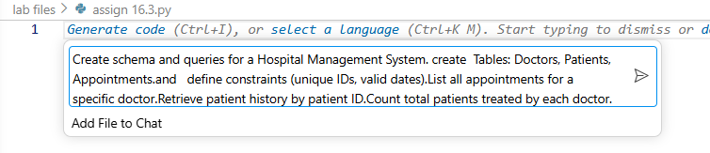  Code:-  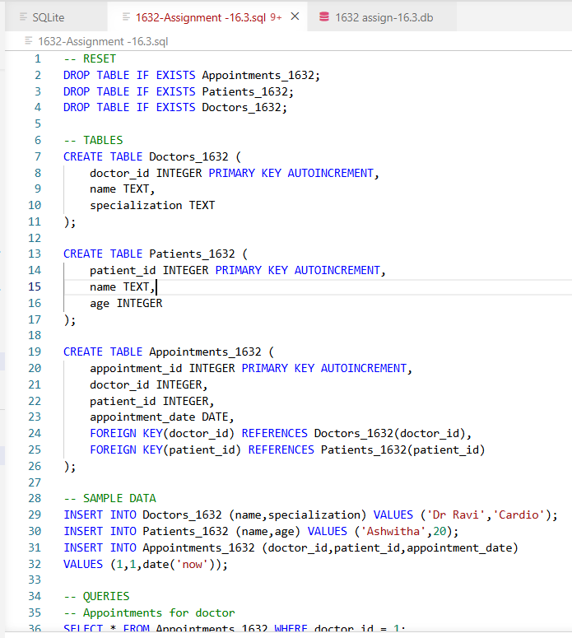  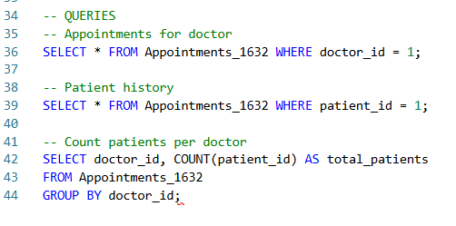  Output:-  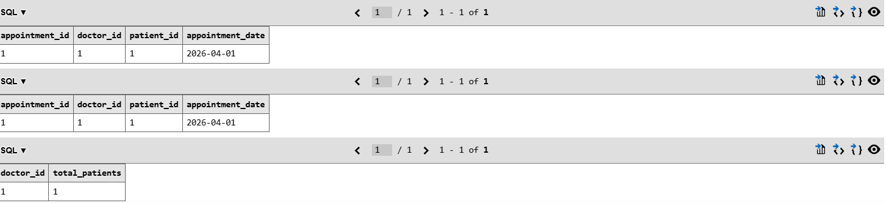  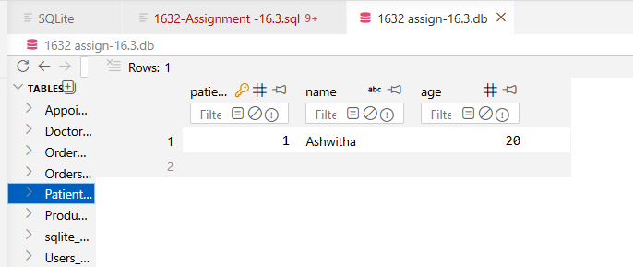  Explanation:-  This system manages hospital data using three tables: Doctors_1632, Patients_1632, and Appointments_1632. Each doctor and patient has a unique ID, and the appointments table connects them using foreign keys. This avoids duplication and maintains proper relationships between data. The system allows us to view appointments of a doctor, check patient history, and count how many patients each doctor has treated. Overall, it shows how relational databases organize and retrieve data efficiently  Task 2 – Real-Time Application: Online Shopping Database  Scenario:  Design a database for an E-commerce platform.  Requirements:  - Tables: Users, Products, Orders, OrderDetails.  - Generate queries to:  - Retrieve all orders by a user.  - Find the most purchased product.  - Calculate total revenue in a given month.  - AI should also suggest normalization improvements and query optimization.  Expected Output:  - Complete schema with relationships + SQL queries for analytics.  Prompt:-  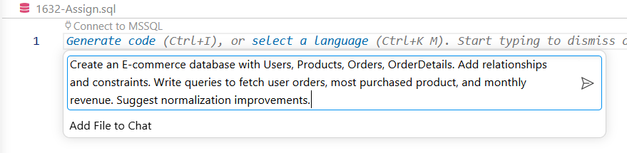  Code:-  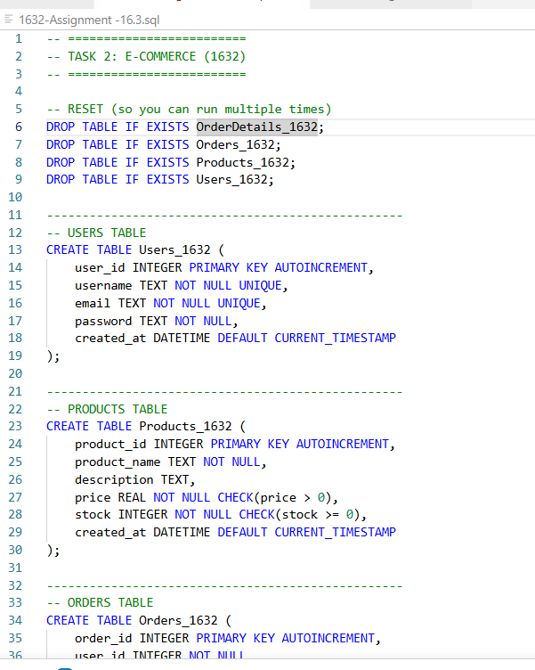  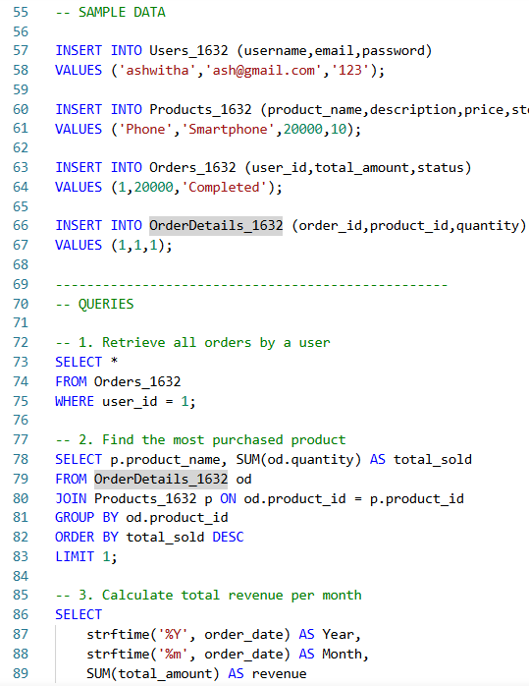  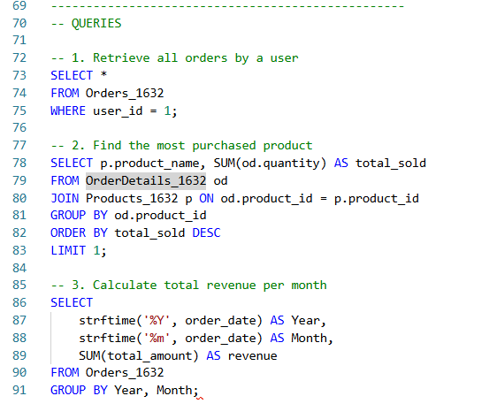  Output:-  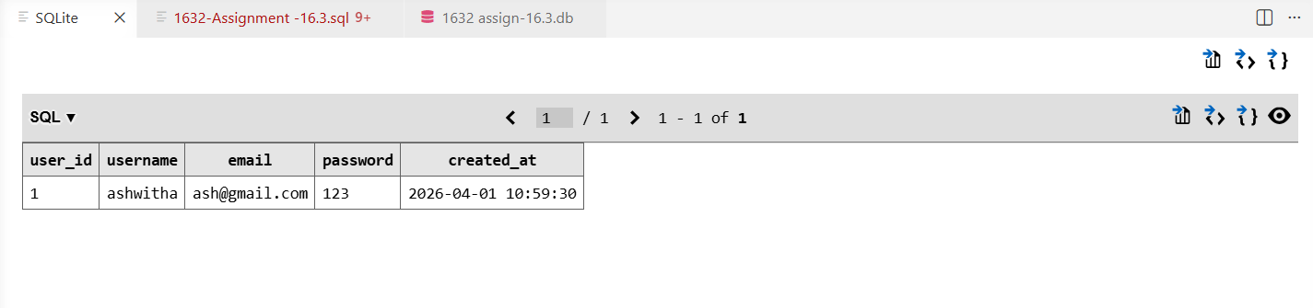  Explanation:-  This database represents an online shopping system with tables for users, products, orders, and order details. The Users_1632 table stores customer information, Products_1632 stores items, Orders_1632 stores purchase details, and OrderDetails_1632 links products with orders. This structure follows normalization and avoids redundancy. Using SQL queries, we can retrieve user orders, find the most purchased product, and calculate monthly revenue. It demonstrates how databases support real-time business operations and analytics.  Task 3 – Library Database  Task:  Design schema for a Library Management System.  Instructions:  - Tables: Books, Members, Loans.  - Use AI to suggest indexing strategy for faster queries.  - Generate queries:  - Retrieve all books currently issued.  - Find overdue books (loan date > 30 days).  - Count number of books loaned by each member.  Expected Output:  - Schema + SQL queries demonstrating joins and conditions.  Prompt:-  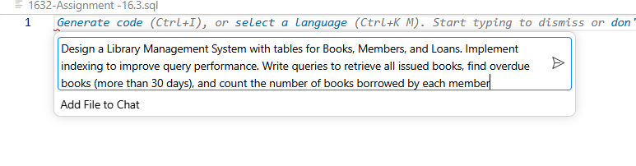  Code:-  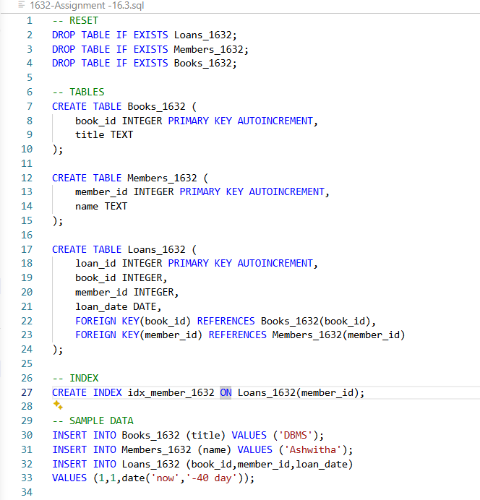  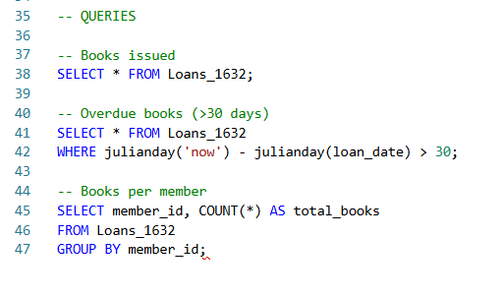  Output:-  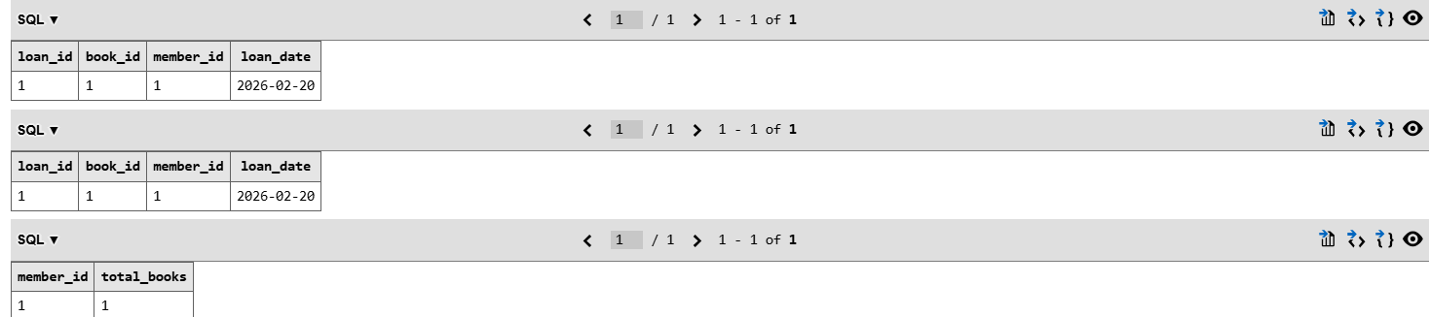  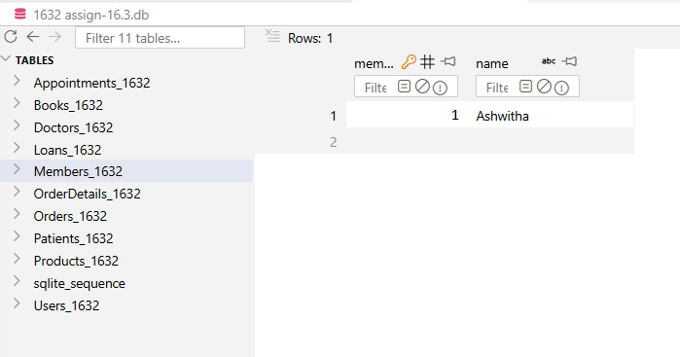  Explanation:-  This system manages books, members, and loan records using three tables: Books_1632, Members_1632, and Loans_1632. When a member borrows a book, it is recorded in the loans table. The system can display issued books, find overdue books using date calculations, and count how many books each member has borrowed. An index is also used to improve search performance. This shows how databases help in tracking and managing records efficiently  Task 4: Optimize Queries  Instructions:  - Use AI tools to analyze query efficiency.  - Optimize inefficient queries using joins, indexes, or reducing subqueries.  - Test optimized queries for correctness.  Starter Code Example:  -- Original query  SELECT * FROM Books WHERE author_id IN (SELECT author_id FROM Authors WHERE country='UK');  -- Optimized query  SELECT b.*  FROM Books b  JOIN Authors a ON b.author_id = a.author_id  WHERE a.country = 'UK';  Expected Output:  - Both queries return the same result: all books written by UK authors.  - Optimized query performs faster for larger datasets  Prompt:-  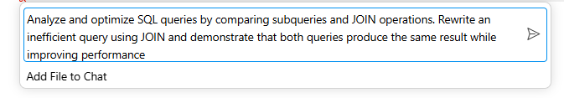  Code:-  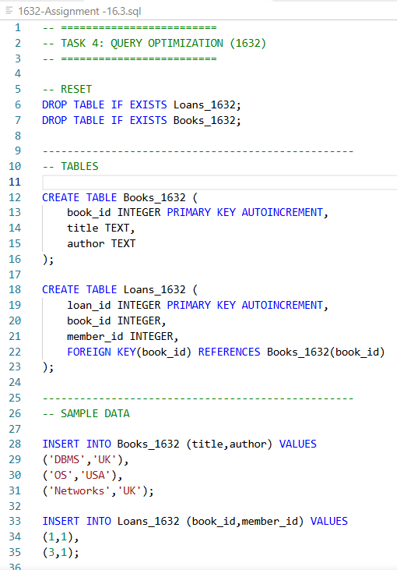  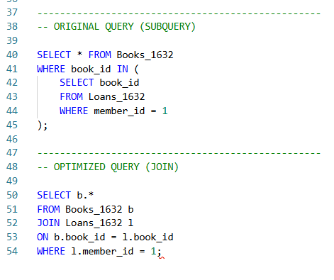  Output:-  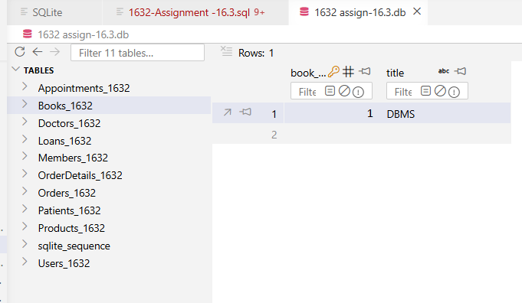  Explanation:-  In this task, two queries were used to retrieve the same data: one using a subquery and the other using a JOIN. Both produced the same output, but the JOIN query is faster and more efficient. This demonstrates the importance of query optimization in databases, where performance can be improved without changing the result.  Task 5: University Course Registration  Scenario:  SR University needs a course registration system for students enrolling in different courses under faculty supervision.  - Use Copilot to design schema tables: Students, Courses, Faculty, and Registrations.  - Define relationships:  - Each student can register for multiple courses.  - Each course is taught by a faculty member.  - Write SQL queries to:  - List all students enrolled in a specific course.  - Find faculty members teaching more than 2 courses.  - Retrieve courses with the highest number of registrations.  Prompt:-  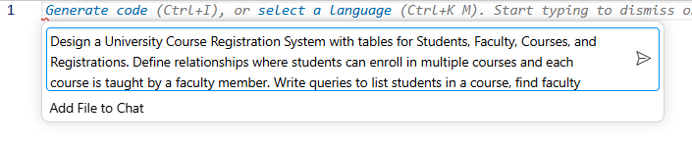  Code:-  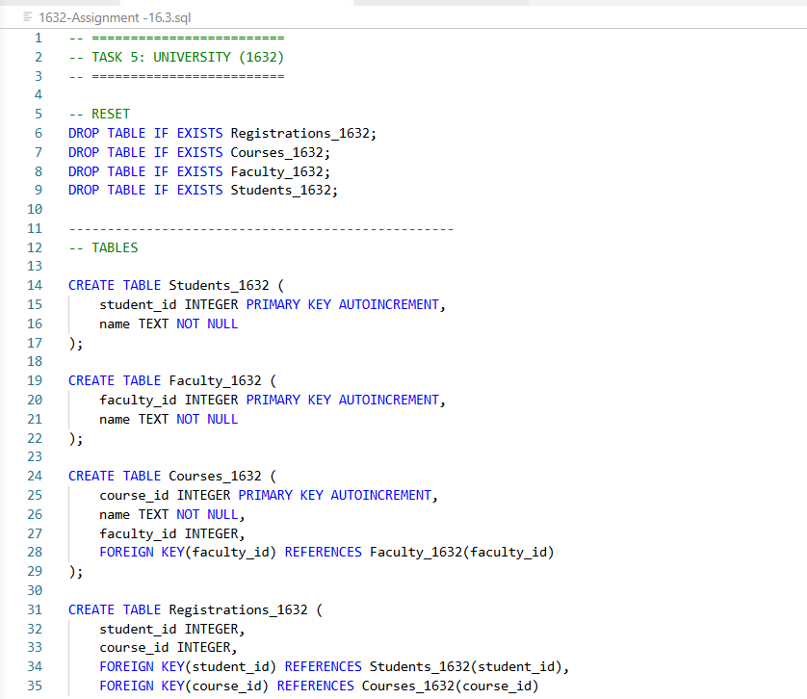  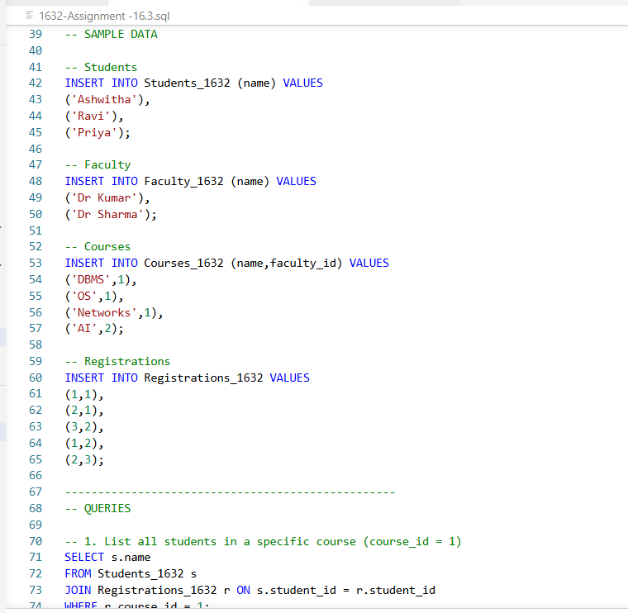  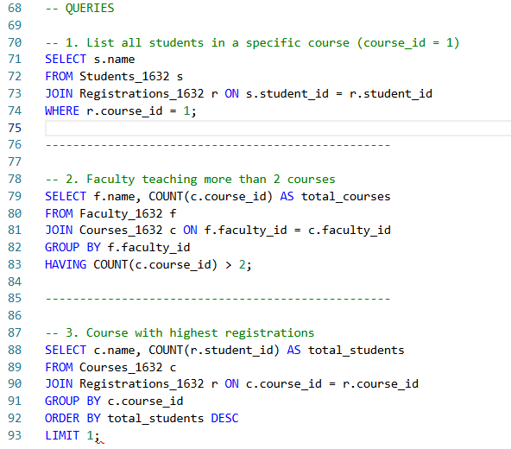  Output:-  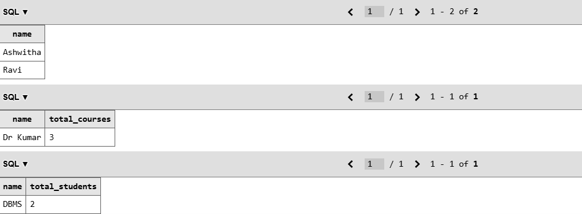  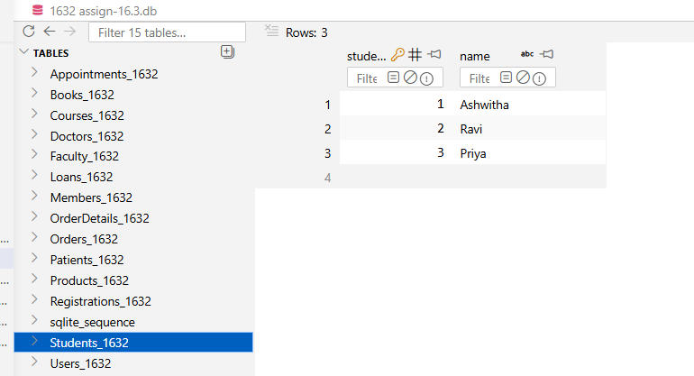  Explanation:-  This system manages student registrations for courses using tables for students, faculty, courses, and registrations. A student can enroll in multiple courses, and each course is taught by a faculty member. The registrations table connects students and courses, forming a many-to-many relationship. Queries are used to list students in a course, find faculty teaching multiple courses, and identify the most popular course. This system shows how databases handle complex relationships and data analysis.  Note: Report should be submitted as a word document for all tasks in a single document with prompts, comments & code explanation, and output and if required, screenshots. |  |  |  |  |  | Week8 - Wednesday

